VIDEO - Financial Foundations

Video: https://www.youtube.com/watch?v=LTJUoy3kQ5c

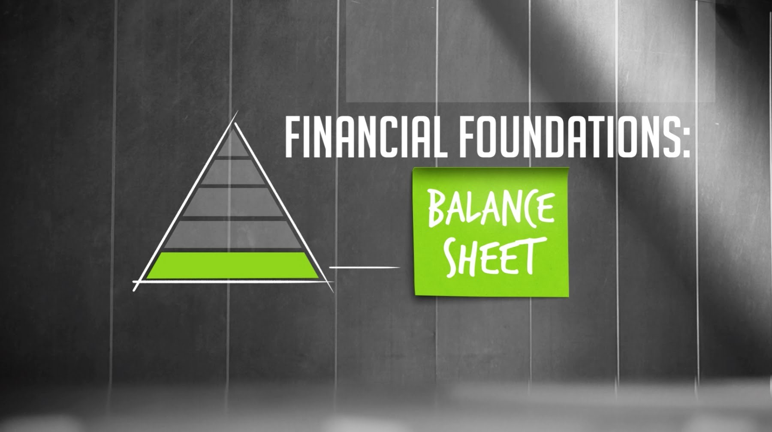

THIS VIDEO CAN HELP ANSWER:
What information is on a balance sheet?
What is included in my liabilities?
What is our debt-to-equity ratio? Why is this important?
What will investors want to know about my balance sheet?

The foundation of your financial structure is your balance sheet. Your balance sheet is a picture of the financial condition of your company at any given point in time. But what I want to talk about today is some of the key points you should be paying attention to. So, you know the balance sheet has on the one hand your assets, and on the other hand your liabilities and the shareholder's equity.
So let's talk a little bit about your assets. Your assets, of course, begin at the top with your cash, probably the most important asset you've got. But in addition to your cash, assets include your short-term assets or your current assets. And that can include accounts receivable, the money you're expected to be paid by your customers. In some cases you'll have inventory, which is product you haven't sold yet but you still have it. So those are your current assets.
You also have long-term assets. Your long-term assets include things like improvements on your building, equipment or servers you've bought. You might even own some property. Put it altogether, those are the assets of your company.

Now the other side of the balance sheet are your liabilities and your shareholder's equity. Your liabilities includes things like debt. They also include your payables. Payables are the money that you owe other people and your accrued liabilities. Accrued liabilities are generally the money you owe people like your employees. And so your payables and your accrued liabilities are considered your short-term liabilities. And that's important because you want to know what things you're going to have to pay off sooner rather than later. Things you have to pay off later would include your long-term debt, money you've borrowed that you don't have to pay off immediately. So you put those things together, those are your liabilities. What's left is your shareholder's equity. So we're going to talk about your shareholder's equity in the next lesson.

When bankers look at your balance sheet, they look at a couple of different things to figure out the health of your company. First thing they are going to look at is your cash. They are going to look to see that you have enough cash to keep going. But a banker also looks at what is called your working capital. Your working capital is more than just the cash, it includes everything that you can convert into cash in a relatively short period of time. Not just your cash, but also your accounts receivable which hopefully will turn into cash pretty soon. The banker takes that working capital number and then subtracts out your short-term liabilities, your accounts payable. That's your net working capital. That really is sort of the nut that you have to work with to keep the company going.
When a banker looks at your balance sheet, they are going to look at the ratio of your debt to your equity. A banker wants to know that you've got plenty of equity in your company. And that, in fact, it is bigger than the amount of debt you have in your company. So if your debt to equity ratio is out of whack, if you have a little more debt than you should, to make a banker or an investor comfortable, how can you fix that problem? The best way to fix it is to increase your equity. The best way to increase your equity is to make profits and add to your retained earnings, which is part of your equity. Improving the performance of your company will naturally improve your debt to equity ratio.

The other thing that's more likely to happen if you're going through a round of investment is investors are going to ask some of the people you've borrowed money from to convert their debt into equity in your company. And that will, of course, improve your debt to equity ratio.
It's really important if ever there's an investor around or a banker around that you can produce the latest, most current balance sheet and capitalization table. The balance sheet you're going to produce each month at the end of each month. So you should have the balance sheet as of the end of the last month. Your capitalization table won't change that often. So we're going to talk about your capitalization table in the next lesson.

ABOUT THE KAUFFMAN FOUNDERS SCHOOL
Visit the website: [http://bit.ly/1EW2br7]
The Kauffman Founders School presents a powerful curriculum for entrepreneurs who wish to learn anywhere, anytime. The online education platform features experts presenting lectures in series modules designed to give Founders a rich learning experience, while also engaging them in lessons that will make a difference in their business today, tomorrow, and in the future.
The Kauffman Founders School series modules include Powerful Presentations, Intellectual Property, Founder's Dilemmas, Entrepreneurial Selling, Entrepreneurial Marketing, Surviving the Entrepreneurial Life, Startups, and much more.
© Ewing Marion Kauffman Foundation.

Aus <https://www.youtube.com/watch?v=LTJUoy3kQ5c>

